Name(s)_______________________________________________ Period ______ Date ___________________
 | Project Guide - Field Collector App | 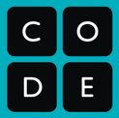

Overview
Having a small, sturdy physical device to carry around in your pocket can help people gather data in tough places and report their results back to a central computer. This is common in construction sites, ecological and geographical surveys, or even surveying people in your community to answer a question. For example, an animal preservation group may need to collect data on how many endangered animals are in an area, so they use an app to go into the field and collect data, then return and analyze the data to make a recommendation.

We’re going to create an app that simulates this experience. Your app will let you collect data with the circuit playground using the buttons or toggle switch. When the data is finished, you can use the app to view the results and display certain information to the user. Your program should also use if-statements to change the result based on the data that was collected.

Program Description
Brainstorm the type of data you would like to collect and what you can do with the results. You may not be able to actually take the circuit playground out into the world, but you can think of this app as a prototype for a future app that you could develop later.

Write a 3-4 sentence description of your app, the data it collects, and how it displays the results to the user.

Sketch Your App
Sketch your app in the screens below. Your app will need at least two screens - one for the data collection, and another to display the results.
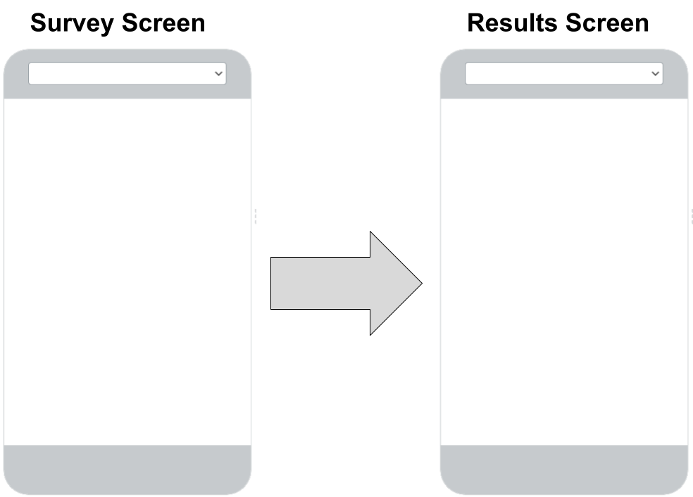

Variables
You’ll need variables to keep track of the data you’re collecting. Make a list of your variables and what they’re keeping track of below.

Variable | What it keeps track of

Inputs
What inputs will your device use? What will change in your code or on the screen?

Input type | What happens when the user interacts with it?

Data Scenarios
Your app should display different results based on the data that is collected. Use the table below to keep track of these different scenarios and how you want to change the screen as a result. You may not use all of the rows in the table, or you can add more if you need to.

Data Scenario | What Happens on the Screen?

Make Your App

Log into Code Studio and make your app in the provided levels

Test Your App

Test your App with multiple users and, if time allows, incorporate feedback from your testing.

Reflect

What part of your project are you most proud of? ____________________________________________________

Why? _______________________________________________________________________________________

_____________________________________________________________________________________________

If you had more time, what improvement would you make to your innovation?

_____________________________________________________________________________________________

_____________________________________________________________________________________________

